Elbow Anatomy Labeling

Bones
- Radius
- Ulna
- Humerus

Bony landmarks
- Olecranon process
- Olecranon fossa
- Medial epicondyle
- Lateral epicondyle
- Radial head
- Capitulum
- Coronoid process
- Coronoid fossa
- Trochlea

Which muscles flex the forearm at the elbow?

Which muscles extend the forearm at the elbow?

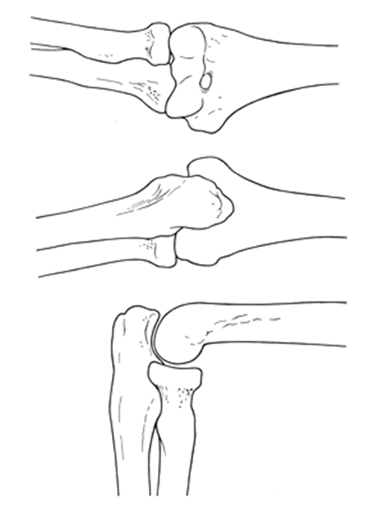
Anterior

Posterior

Lateral

