Wrist and Hand Anatomy Labeling

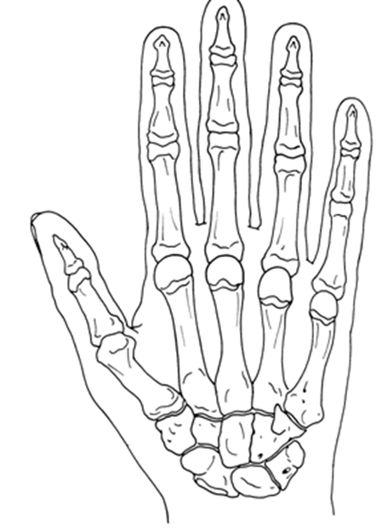
Bones
Phalanges (14)
- Middle
- Distal
- Proximal
Metacarpals (5)
- I
- II
- III
- IV
- V
Carpals (8)
- Scaphoid (Navicular)
- Lunate
- Triquetrum
- Pisiform
- Trapezium
- Trapezoid
- Capitate
- Hamate

What muscles flex the wrist?

Left Hand Palmer View

What muscles extend the wrist?

What muscle does supination of the hand?

What muscles pronate the hand?

What is the Latin word for “thumb”?

